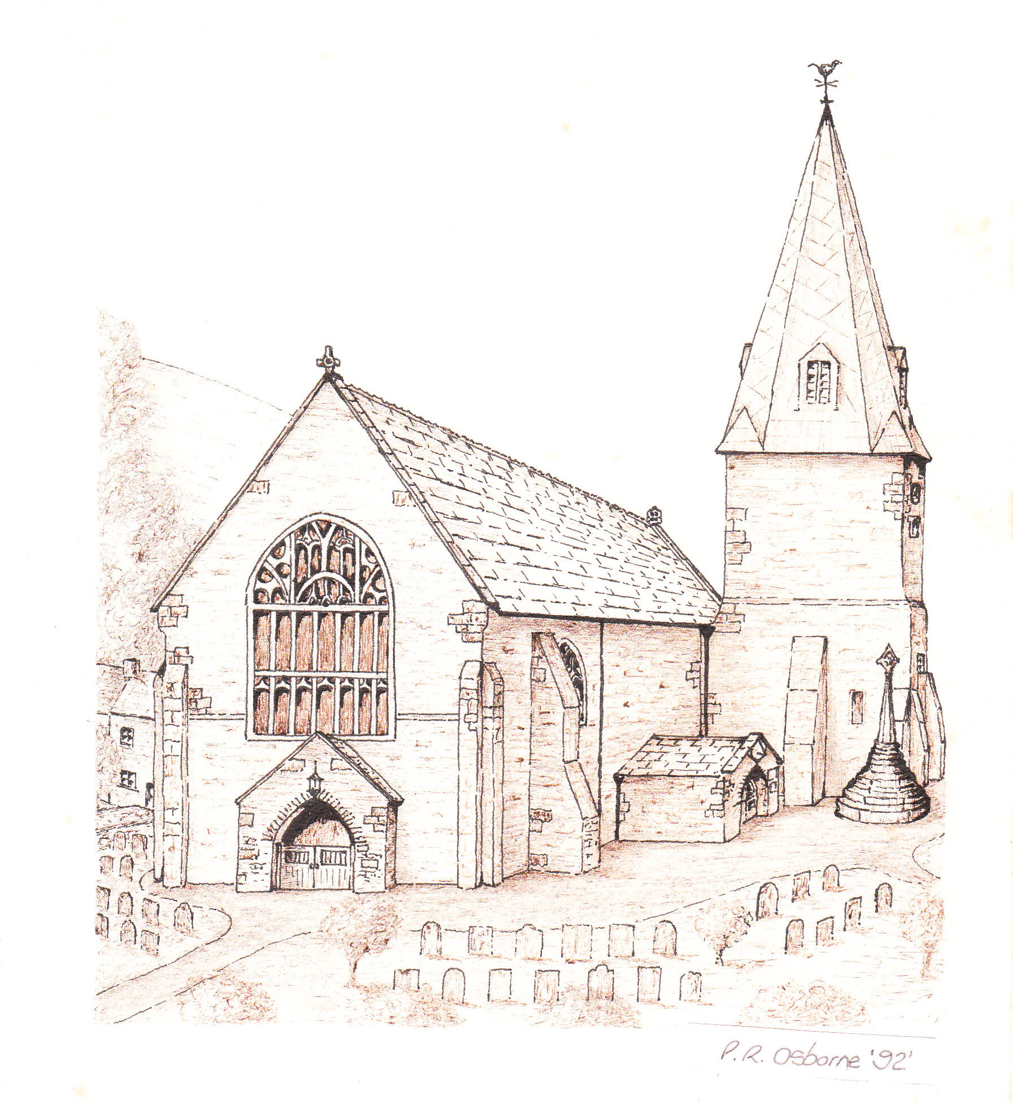
ST BRANNOCK’S CHURCH
BRAUNTON

SPRING FAYRE

SATURDAY

MARCH 14th

BRAUNTON PARISH HALL
10.00am -12noon
Plants
Bric a brac
Books
Crafts
Jewellery

Cakes
Tombola
Raffle
Lucky squares
Scarves




Refreshments
Coffee - Tea
Refreshments

EVERYONE WELCOME
Braunton Mission Community – St Brannock’s with St Anne’s

